Inventors Association of Connecticut Holiday Party

When: Saturday December 11th 2010
Where: Alumni House, Fairfield University
Time: 3:00PM to 7:00PM

This years’ IACT Holiday Party will be on the Fairfield University Campus
and is sponsored by the Engineering Student Society (ESS). This event will allow
Fairfield Engineering Students to engage with the core of IACT. It is hoped
that this will plant seeds of invention among the ESS group.

Each IACT member is allowed to bring guests. Bring an appetizer or entrée of your choosing.
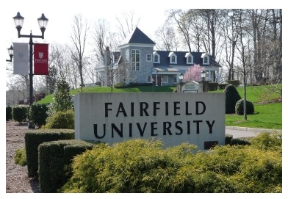
The Alumni House is shown just behind the Main Entrance

Parking: Just above the Alumni House across from Mcauliffe Hall, Building 22 on the map, below
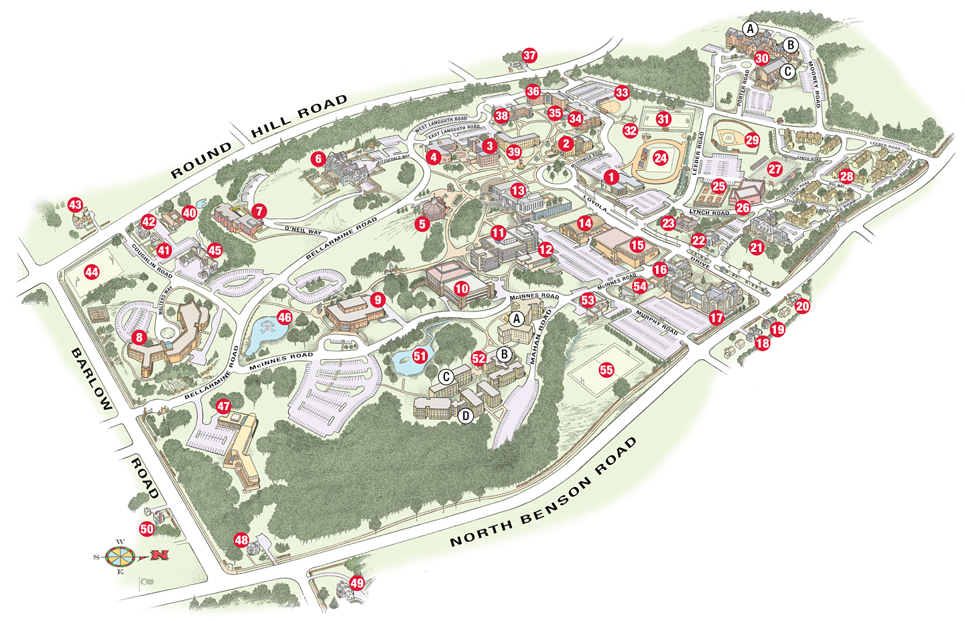
It is in the parking lot across from McCaullife;
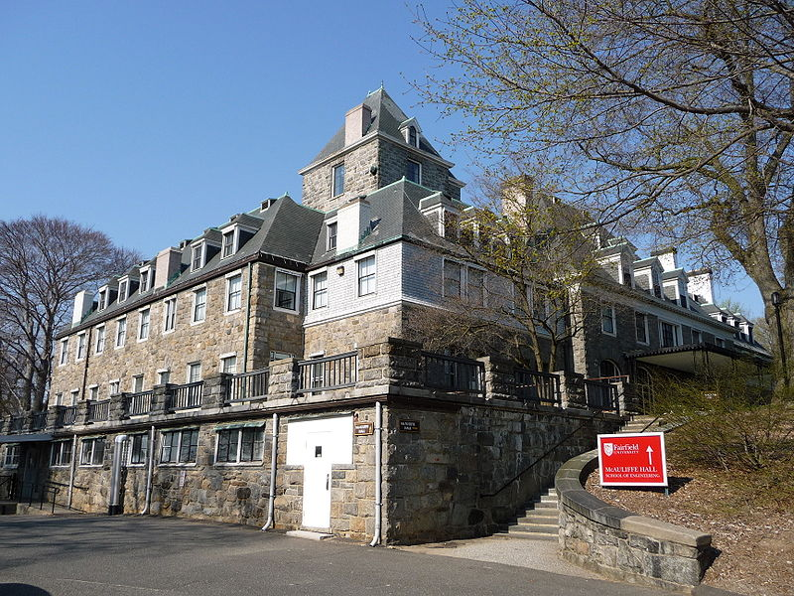
Send your RSVP to Chad Lyons at c.lyons@snet.net. Include the food item you plan to bring and the number of guests.

